Sprint 1 Week 1

Jobs

As a wheelchair user I want a character model that represents myself so that I can relate to it better while playing the game.

* Estimated Time: 4 hours
* Acceptance Criteria: 3D model of a wheelchair on skis
* Acceptance Criteria: Textured model of a wheelchair on skis
* Acceptance Criteria: Max 1000 polys - Aim for 750
* Status: <Adam>

As an avid gamer I want my inputs to be shown on screen through character animations so that the game is more immersive

* Estimated Time: 2 hours
* Acceptance Criteria: Animated player avatar that moves along with the users chair
* Acceptance Criteria: Universal interface for use with any control system
* Acceptance Criteria: Angle set with a value between 1 and -1, 0 is center point
* Status: <Adam>

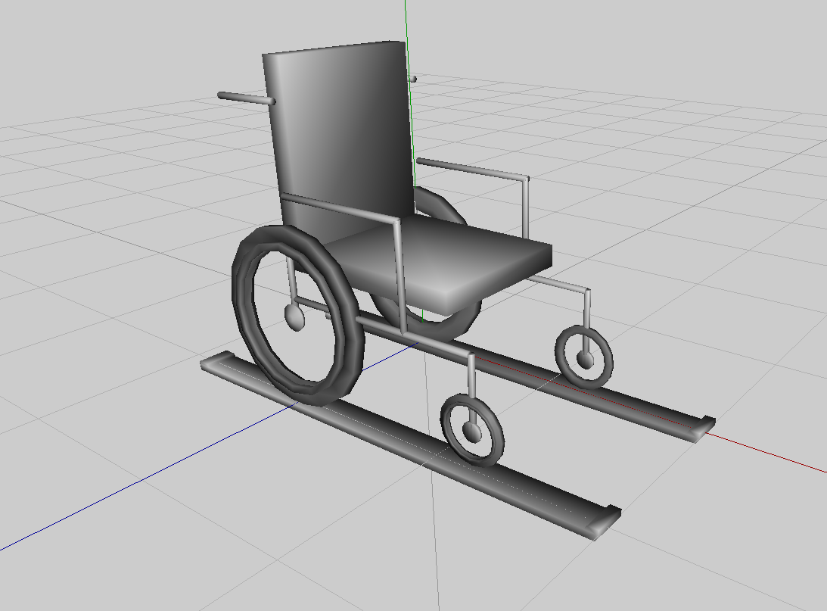Polygons for model = 956